**JavaMenu:**

import javax.swing.*;

**Output:**

import java.awt.event.ActionEvent;

import java.awt.event.ActionListener;

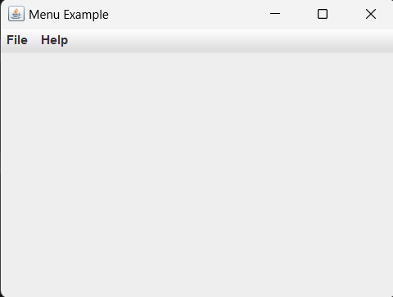public class MenuExample {

public static void main(String[] args) {

// Create a JFrame

JFrame frame = new JFrame("Menu Example");

frame.setDefaultCloseOperation(JFrame.EXIT_ON_CLOSE);

frame.setSize(400, 300);

// Create a JMenuBar

JMenuBar menuBar = new JMenuBar();

// Create File menu and its items

JMenu fileMenu = new JMenu("File");

JMenuItem newItem = new JMenuItem("New");

JMenuItem openItem = new JMenuItem("Open");

JMenuItem saveItem = new JMenuItem("Save");

JMenuItem exitItem = new JMenuItem("Exit");

// Add action listeners to menu items

exitItem.addActionListener(new ActionListener() {

@Override

public void actionPerformed(ActionEvent e) {

System.exit(0);

}

});

// Add menu items to File menu

fileMenu.add(newItem);

fileMenu.add(openItem);

fileMenu.add(saveItem);

fileMenu.addSeparator(); // Add a separator line

fileMenu.add(exitItem);

// Create Help menu and its items

JMenu helpMenu = new JMenu("Help");

JMenuItem aboutItem = new JMenuItem("About");

// Add action listeners to menu items

aboutItem.addActionListener(new ActionListener() {

@Override

public void actionPerformed(ActionEvent e) {

JOptionPane.showMessageDialog(null, "This is an example Swing menu application.");

}

});

// Add menu items to Help menu

helpMenu.add(aboutItem);

// Add menus to the menu bar

menuBar.add(fileMenu);

menuBar.add(helpMenu);

// Set the menu bar for the frame

frame.setJMenuBar(menuBar);

// Make the frame visible

frame.setVisible(true);

}

}

**Event Handeling:**

**Output:**

import javax.swing.*;

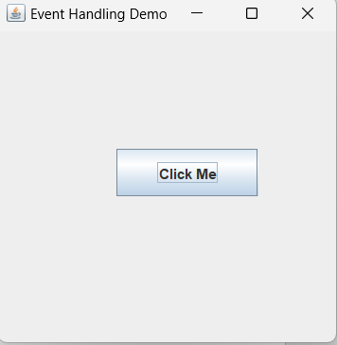import java.awt.event.*;

public class EventHandling {

public static void main(String[] args) {

JFrame frame = new JFrame("Event Handling Demo");

JButton button = new JButton("Click Me");

button.setBounds(100, 100, 120, 40);

button.addActionListener(new ActionListener() {

public void actionPerformed(ActionEvent e) {

JOptionPane.showMessageDialog(frame, "Button Clicked!");

}

});

frame.add(button);

frame.setSize(300, 300);

frame.setLayout(null);

frame.setVisible(true);

frame.setDefaultCloseOperation(JFrame.EXIT_ON_CLOSE);

}

}

**Dialog Example:**

import java.awt.*;

import java.awt.event.*;

**Output:**

public class DialogExample {

private static Dialog d;

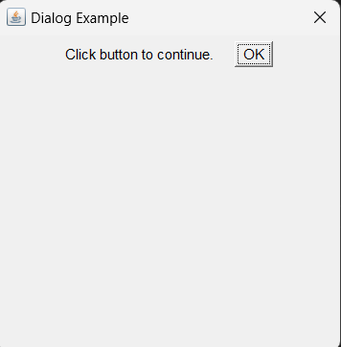DialogExample() {

Frame f= new Frame();

d = new Dialog(f , "Dialog Example", true);

d.setLayout( new FlowLayout() );

Button b = new Button ("OK");

b.addActionListener ( new ActionListener()

{

public void actionPerformed( ActionEvent e )

{

DialogExample.d.setVisible(false);

}

});

d.add( new Label ("Click button to continue."));

d.add(b);

d.setSize(300,300);

d.setVisible(true);

}

public static void main(String args[])

{

new DialogExample();

}

}

**Login Form:**

**Output:**

import javax.swing.*;

import java.awt.*;

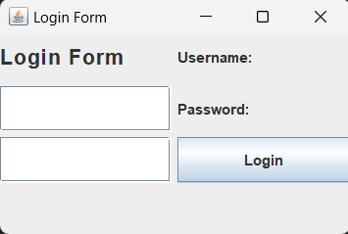import java.awt.event.ActionEvent;

import java.awt.event.ActionListener;

public class LoginForm extends JFrame {

private JLabel titleLabel, usernameLabel, passwordLabel;

private JTextField usernameField;

private JPasswordField passwordField;

private JButton loginButton;

public LoginForm() {

setTitle("Login Form");

setSize(300, 200);

setDefaultCloseOperation(JFrame.EXIT_ON_CLOSE);

setLayout(new GridLayout(4, 2, 5, 5));

titleLabel = new JLabel("Login Form");

titleLabel.setFont(new Font("Arial", Font.BOLD, 18));

add(titleLabel);

usernameLabel = new JLabel("Username:");

add(usernameLabel);

usernameField = new JTextField();

add(usernameField);

passwordLabel = new JLabel("Password:");

add(passwordLabel);

passwordField = new JPasswordField();

add(passwordField);

loginButton = new JButton("Login");

loginButton.addActionListener(new ActionListener() {

@Override

public void actionPerformed(ActionEvent e) {

String username = usernameField.getText();

String password = new

String(passwordField.getPassword());

if (username.equals("admin") &&

password.equals("admin123")) {

JOptionPane.showMessageDialog(LoginForm.this,"Login Successful!");

} else {

JOptionPane.showMessageDialog(LoginForm.this,

"Invalid Username or Password", "Error", JOptionPane.ERROR_MESSAGE);

}

}

});

add(loginButton);

setVisible(true);

}

public static void main(String[] args) {

SwingUtilities.invokeLater(new Runnable() {

@Override

public void run() {

new LoginForm();

}

});

}

}